#include <stdio.h>

#define MAX 50

// Structure for each region
struct Region {
char name[50];
int population;
int severity;
int priority;
int allocated;
};

int main() {

struct Region R[MAX];
int n, i;
int totalResources;
int valid = 1;

printf("=== DISASTER RELIEF RESOURCE ALLOCATION SIMULATOR ===\n");

// ---------------------------------------
// Input Region Details
// ---------------------------------------
printf("Enter number of regions: ");
scanf("%d", &n);

for (i = 0; i < n; i++) {
printf("\nEnter name of Region %d: ", i + 1);
scanf("%s", R[i].name);

printf("Enter population of %s: ", R[i].name);
scanf("%d", &R[i].population);

printf("Enter severity score (1–10) for %s: ", R[i].name);
scanf("%d", &R[i].severity);

// Validity check (flowchart: Are inputs valid?)
if (R[i].severity < 1 || R[i].severity > 10 || R[i].population < 0) {
valid = 0;
}
}

// ---------------------------------------
// Enter available resources
// ---------------------------------------
printf("\nEnter total available resources: ");
scanf("%d", &totalResources);

if (totalResources < 0) {
valid = 0;
}

// If inputs invalid → go back (flowchart "No" arrow)
if (valid == 0) {
printf("\nInvalid inputs! Please restart the program.\n");
return 0;
}

// ---------------------------------------
// Compute priority levels
// ---------------------------------------
int totalPriority = 0;

for (i = 0; i < n; i++) {
R[i].priority = R[i].population * R[i].severity;
totalPriority += R[i].priority;
}

// ---------------------------------------
// Allocate resources based on priority
// ---------------------------------------
int totalAllocated = 0;

for (i = 0; i < n; i++) {
R[i].allocated = (R[i].priority * totalResources) / totalPriority;
totalAllocated += R[i].allocated;
}

// ---------------------------------------
// Are resources sufficient?
// ---------------------------------------
if (totalAllocated > totalResources) {
printf("\n** RESOURCE SHORTAGE ALERT **\n");
printf("Not enough resources for all regions!\n");
}

// ---------------------------------------
// Display Final Allocation Report
// ---------------------------------------
printf("\n=========== FINAL ALLOCATION REPORT ===========\n");
printf("%-15s %-12s %-10s %-10s\n",
"Region", "Population", "Severity", "Allocated");

for (i = 0; i < n; i++) {
printf("%-15s %-12d %-10d %-10d\n",
R[i].name, R[i].population, R[i].severity, R[i].allocated);
}

printf("===============================================\n");
printf("Simulation Completed.\n");
return 0;
}
OUTPUT:
Step1:
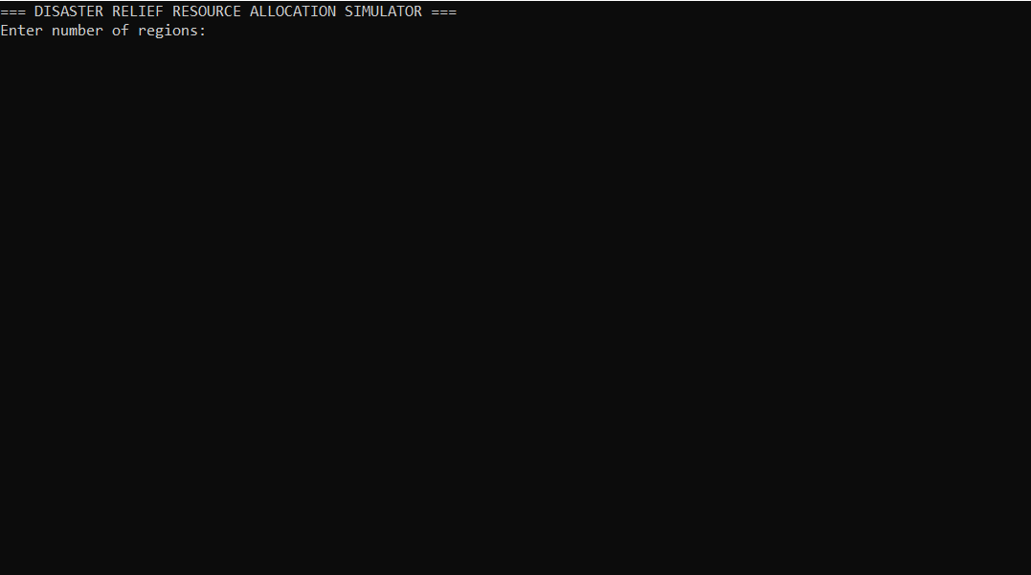

Step2:
